National Association of University Women Southwest Sectional Conference
50th Anniversary

Celebrating Our Past, Inspiring Our Future

South Bay Branch Conference Host www.nauwsouthbay.org

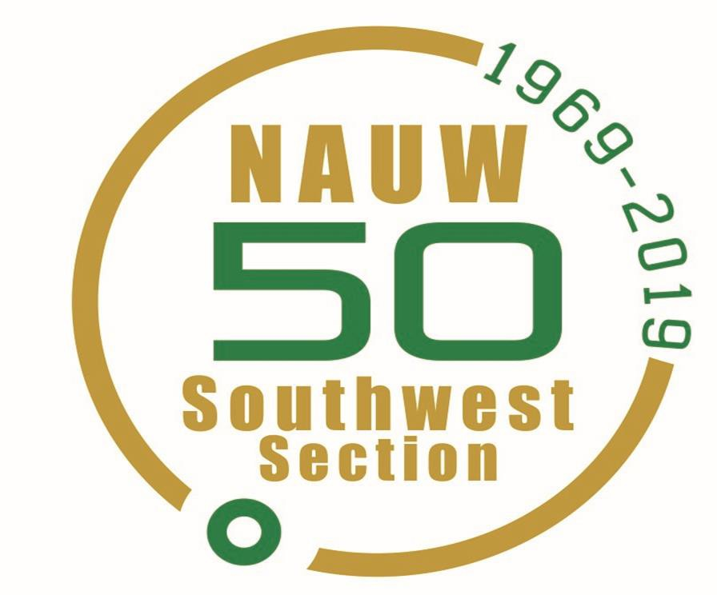

February 1-2, 2019

Renaissance Los Angeles Airport Hotel 9620 Airport Blvd, Los Angeles, Ca 90045

National Association of University Women (NAUW) 50th Southwest Sectional Conference
South Bay Branch, Conference Host

Dear Southwest Sectional Member:
The South Bay Branch will serve as your host for the 50th Southwest Sectional Conference. Members of South Bay Branch and the Sectional Director are busy planning activities that will provide you with an exciting and memorable experience.
The Theme of the conference is: “Celebrating Our Past, Inspiring our Future”
and will highlight growth and advancement in this constantly changing world.
Our workshops will focus on the theme “Guiding the Way through the 21st Century” and will feature presentations by noted experts on strategies for branch success.

We are so excited to bring this event to you while laughing and sharing our experience these past 50 years!

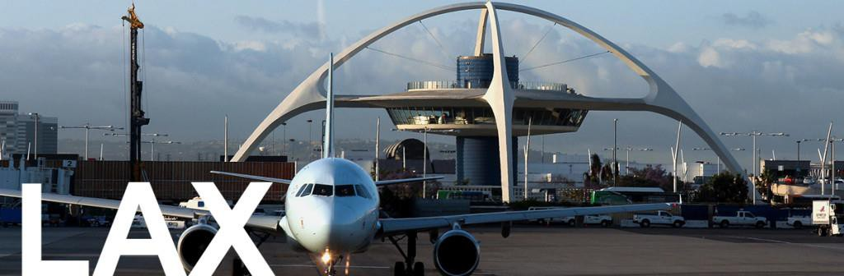

Registration

Dates and Deadlines
$180 | Early Registration Deadline | December 1, 2018
$190 | Regular Registration | December 2-31, 2018
$200 | Late Registration | January 1-25, 2018
$225 | Registration at the Conference | February 1-2, 2018

Registration includes
- Friday Night Glitz and Glam Extravaganza Dinner 6:00 pm –11:00 pm Dress – Formal. (Gold is highly encouraged to celebrate our Golden Anniversary) Saturday Activities (Dress is White and/or Green)

Sectional Director’s Breakfast Buffet 7:00am – 8:15am
- Founders Day Luncheon 11:00am- 12:30p
- Saturday Workshops
- Sectional Conference Materials Registration by Check Or Pay Pal:
  - Complete your registration form
  - Make check made payable to your Branch
  - Give check and Registration Form to your Branch designated person
  - The Branch Treasurer is requested to make one check payable to NAUW – South Bay
and send to:
Edna Yow
2902 Victoria Ave
Los Angeles, Ca 90016
Or Register Online: www.nauwsouthbay.org (small fee reflected in online price)

General Information Conference Registration Times:
Friday, February 1, 2019 3:00 pm to 6:00 pm
Saturday, February 2, 2019 7:15 am to 9:00 am

We are very excited about serving as your conference host and look forward to seeing you at the conference.

Sincerely,
Margarette Crockett, President
Essie French-Preston, Sectional Director
Barbara Clark, Bernice Shannon, Edna Yow, Sectional Conference Committee Co- Chairs

Hotel Information

Renaissance Los Angeles Airport Hotel

9620 Airport Blvd, Los Angeles, Ca 90045 (310) 337-2800

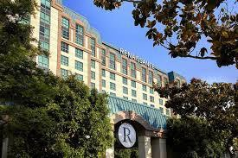
The 50th Southwest Sectional Conference will be held on February 1 & 2 at the newly-renovated Renaissance Los Angeles Airport Hotel.
The Renaissance is an eclectic departure from the typical airport hotel. Where vinyl records grace the walls, and an urban style permeates the air. Representing LA’s cosmopolitan vibe—on your own way and on your own time.

Room Reservations

Dates: 2/1/19 – 2/2/19

ROOM Rate: $119 Single and Double Occupancy, plus tax and hotel fees

Booking Link: https://tinyurl.com/50yearSW Or
Call for Reservation (310) 337-2800 (Ask for NAUW rate)
Last Day to Book: January 12, 2019 Parking is discounted to $15 for Overnight Self-Parking
$45 for Valet.

NATIONAL ASSOCIATION OF UNIVERSITY WOMEN (NAUW)

49th Southwest Sectional Conference February 1 – 2, 2019
“A Legacy of Service and Commitment in Action”
South Bay Conference Host Branch Registration Form

Name Branch:

Address City/zip

Email

Check One: Member ( ) Sectional Officer: National Officer:
Past Sectional Director ( ) | 1st Time Attendee | ( )
Early Registration, before Dec. 1, 2018 | $180.00
Regular Registration starting Dec.1 until Dec 31 | $190.00
Late Registration after December 31 until January 10, 2018 | $200.00
NO REFUNDS FOR NO SHOWS

REGISTRATION INCLUDES: Conference Materials, Friday Night Glitz and Glam Extravaganza Dinner, Sectional Director’s Breakfast, and Founders’ Day Luncheon

Please indicate your preference for Vegetarian Meal: Friday Dinner Saturday Luncheon EXTRA TICKETS for Guest (s) (indicate number of tickets)
Friday Dinner/ Event (Vegetarian ) Tickets @ $75 ea. Total

Saturday
Sectional Director’s Breakfast Tickets @ $45ea. Total Founders’ Luncheon (Vegetarian ) Tickets @ $50 ea. Total

Registration & Extra Tickets Grand Total Enclosed: $

Make Branch Check or Money Orders Payable to: NAUW South Bay Branch
Mail Registration Forms & checks to
Edna Yow
2902 Victoria Ave
Los Angeles, Ca 90016

Or Register online at www.nauwsouthbay.org
(additional charge reflected in online price)

National Theme “A Legacy of Service and Commitment in Action”

50th Annual Southwest Sectional Conference February 1 - 2, 2019
South Bay Conference Host Branch
Ads Form
Sectional Souvenir Program Book Deadline to Submit, January 2, 2019

The souvenir journal gives us an opportunity to solicit those businesses that we patronize and ask for their support of our organization. It is also a means of highlighting branch and sectional programs. In addition, we can announce events, acknowledge individuals/organizations, offer congratulations, tributes and/or memorials to family, friends, staff, and/or branch members. Each branch is encouraged to purchase at least a full page ad. Thank you for your support.
Please submit your “camera-ready” ad as an attached word document or as a PDF file according to the specifications below:

Please Check:
Front Inside Cover | 7 ½” Wide x 10” Long | $ 350.00
Back Cover Page | 7 ½” Wide x 10” Long | $ 500.00
Back Inside Cover Page | 7 ½” Wide x 10” Long | $ 350.00
Full Page | 7 ½” Wide x 10” Long | $ 100.00
½ Page | 7 ½” Wide x 4 ¾” Long | $ 60.00
¼ Page | 3 ½” Wide x 4 ¾” Long | $ 35.00
Business Card | 2” Wide x 3 ½ Long | $ 20.00
Patron Listing | Name Only – one line | $ 5.00

Total Amount Enclosed for Ads $
Please Complete:

Name: Branch/ Company: Street Address: City: State: Zip Code: Telephone: Email:
Enclose Cashier’s check, money order, or branch check payable to
NAUW South Bay Branch

Mail to Barbara Clark, 21440 Vera St, Carson, CA 90745

Email your ad to lovefannie@hotmail.com
Fannie Love

NAUW Southwest Sectional Souvenir Program Chair

50th Annual Southwest Sectional Conference February 1 - 2, 2019
South Bay Conference Host Branch

Vendor Registration Form

Business Name: Contact Name: Telephone Contact: Mailing address: Website:
E-Mail: Types Of Merchandise:

Vendor Fee is $80 (Non-Refundable)
Dates/Times: Friday, February 1, 2019 3:30pm – 11:00pm Saturday, February 2, 2019 10:00am – 5:00pm

Vendors will be provided one (1) 6’ long table and two (2) Chairs. Space Should be kept clean and neat. Each vendor is asked to provide one item to be used as door prize at this event.
Deadline for registration and fee payment is January 15th, 2019 to reserve your space. If you would like to purchase a Conference meal:
Friday Night Evening | $75/ticket | (Vegetarian )
Saturday Breakfast Buffet | $45/ticket
Saturday Lunch | $50/ticket | (Vegetarian )

Amount Enclosed: $

Please Make your vendor fee and Conference meal check payable to
NAUW South Bay Branch
Mail to Barbara Clark, 21440 Vera St, Carson, CA 90745 or make payment online at www.nauwsouthbay.org

